Membership Form
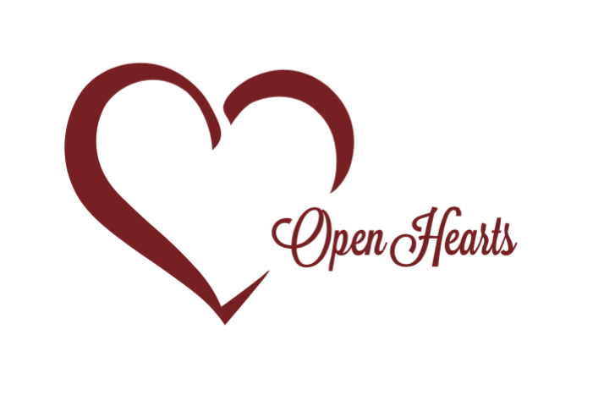 | Open Heart Communities Corp  Open Heart Communities is dedicated to bridging the gap between foster care, residential care, and reunification today, to give children a better tomorrow.

Donor Information (please print or type)

Name

Billing address

City, ST Zip Code

Phone 1 | Phone 2

Fax | Email

Membership
I pledge a membership of: ☐Basic ($25/mo.) ☐Premium ($40/mo.)
Basic: Monthly newsletter, quarterly professional development courses, OHC’s annual t-shirt
Premium: Basic + 2 tickets to annual gala
T-Shirt Size: ☐Sm. ☐Med. ☐Lrg. ☐Xlrg.
I plan to make this contribution in the form of autopay from the following card:

Credit card type | Exp. date

Credit card number

Authorized signature

Signature(s) |  | Date
Please make checks, corporate matches,  or other gifts payable to:  Please mail or email this form to: |  | Open Heart Communities Corp  26340 Clarita  Redford, MI 48240  admin@openheartcommunities.org

