Sponsorship Form
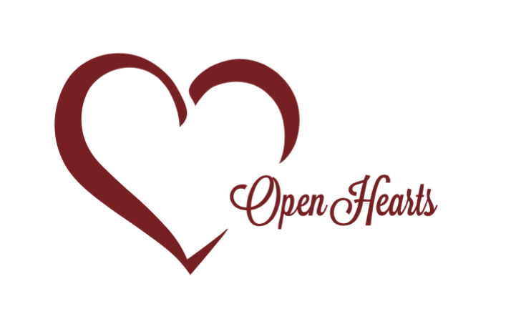 | Open Heart Communities Corp  Open Heart Communities is dedicated to bridging the gap between foster care, residential care, and reunification today, to give children a better tomorrow.

Donor Information (please print or type)

Company Name

Rep Name

Billing address

City, ST Zip Code

Phone 1 | Phone 2

Fax | Email

Sponsorship
I (we) pledge a sponsorship of: ☐Bronze ($1000) ☐Silver (5000) ☐Gold ($10,000)
Bronze: Newsletter, quarterly professional development courses, link & logo on website & social media and recognition in newsletter
Silver: Bronze + 2 Gala tickets
Gold: Silver + Premier recognition at gala
I (we) plan to make this contribution in the form of: ☐cash ☐check ☐credit card ☐paid online

Credit card type | Exp. date

Credit card number

Authorized signature

Acknowledgement Information
Please use the following name(s) in all acknowledgements:

☐I (we) wish to have our gift remain anonymous.
Signature(s) |  | Date
Please make checks, corporate matches,  or other gifts payable to:  Please mail or email this form to: |  | Open Heart Communities Corp  26340 Clarita  Redford, MI 48240  admin@openheartcommunities.org

